**Guidelines for Xampp Server Installation**

1. Go to the official XAMPP website at apachefriends.org.

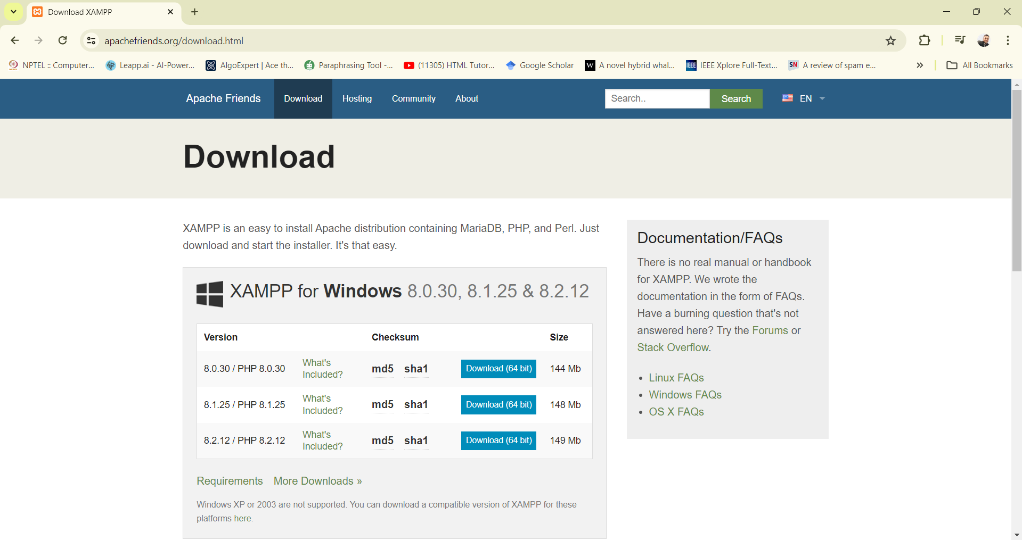

1. Download the XAMPP installer appropriate for your operating system (Windows, macOS, or Linux).

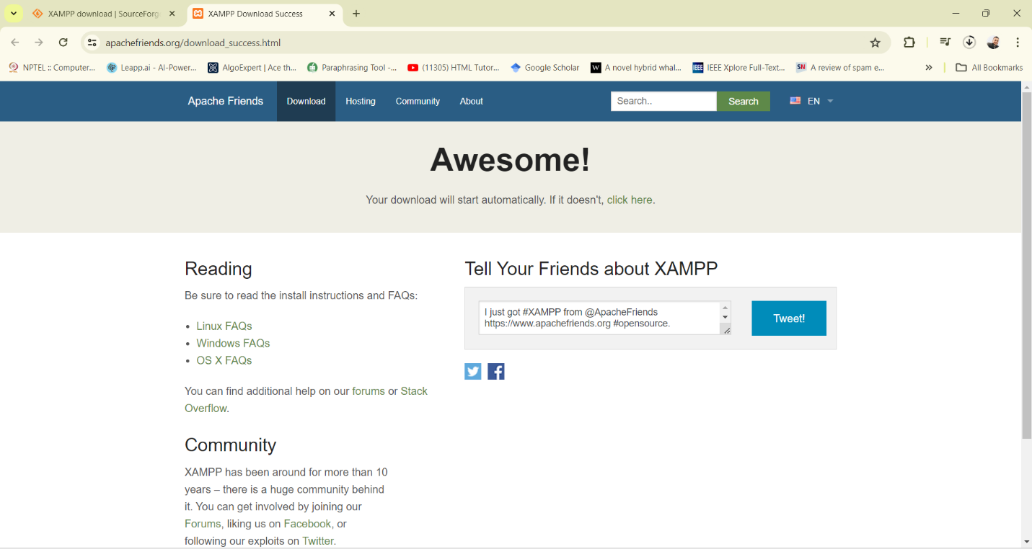

1. Locate the downloaded installer file and double-click it to run the installer.

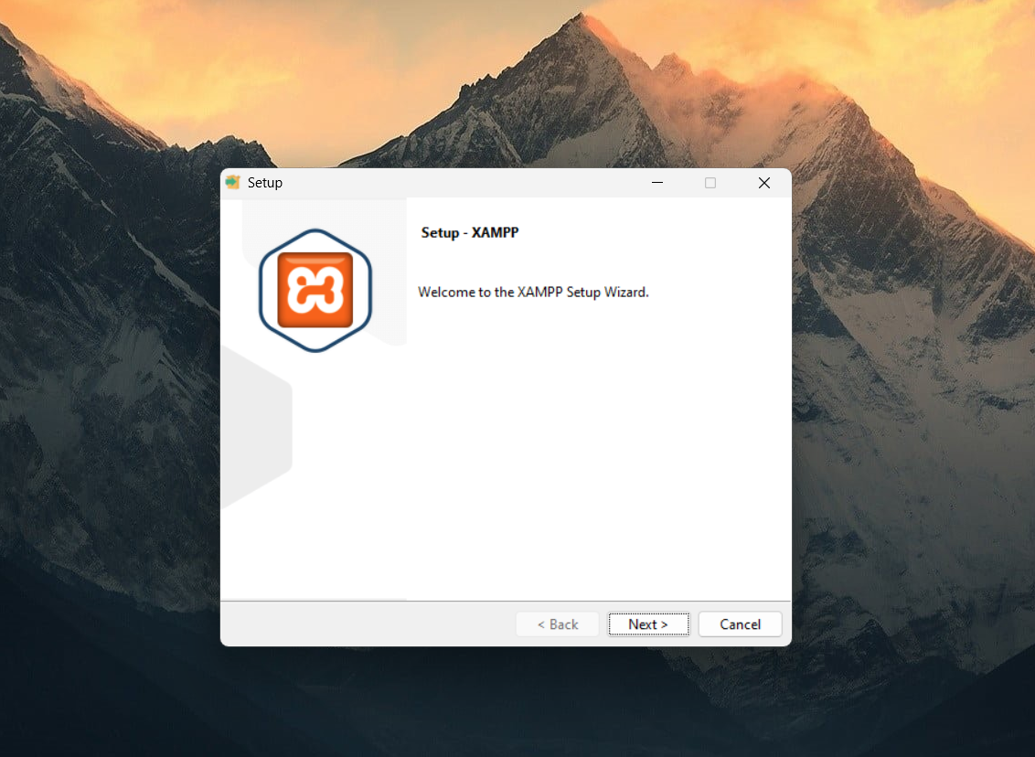

1. If prompted by the User Account Control on Windows, click "Yes" to allow the installer to make changes to your system.



1. The installer will present a list of components to install (e.g., Apache, MySQL, PHP, phpMyAdmin). By default, all components are selected. You can deselect any components you do not need.

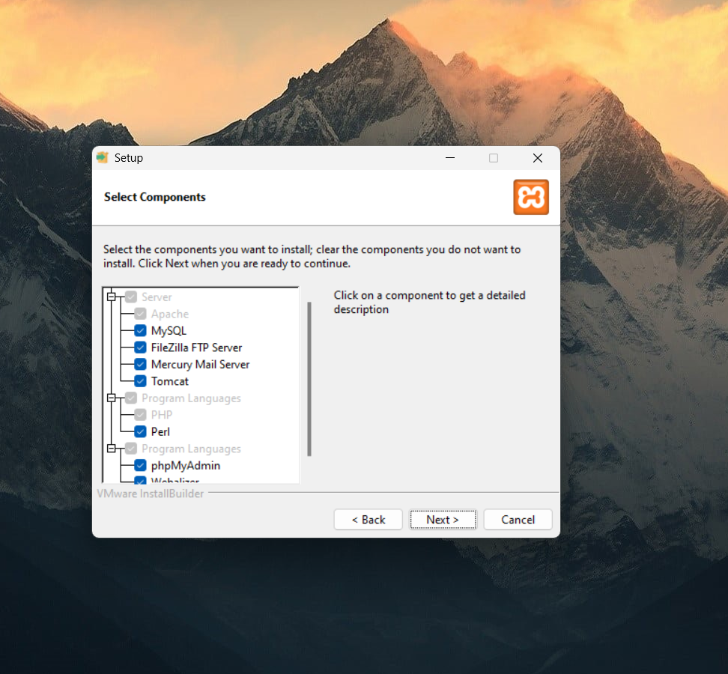

1. Click "Next" to continue.

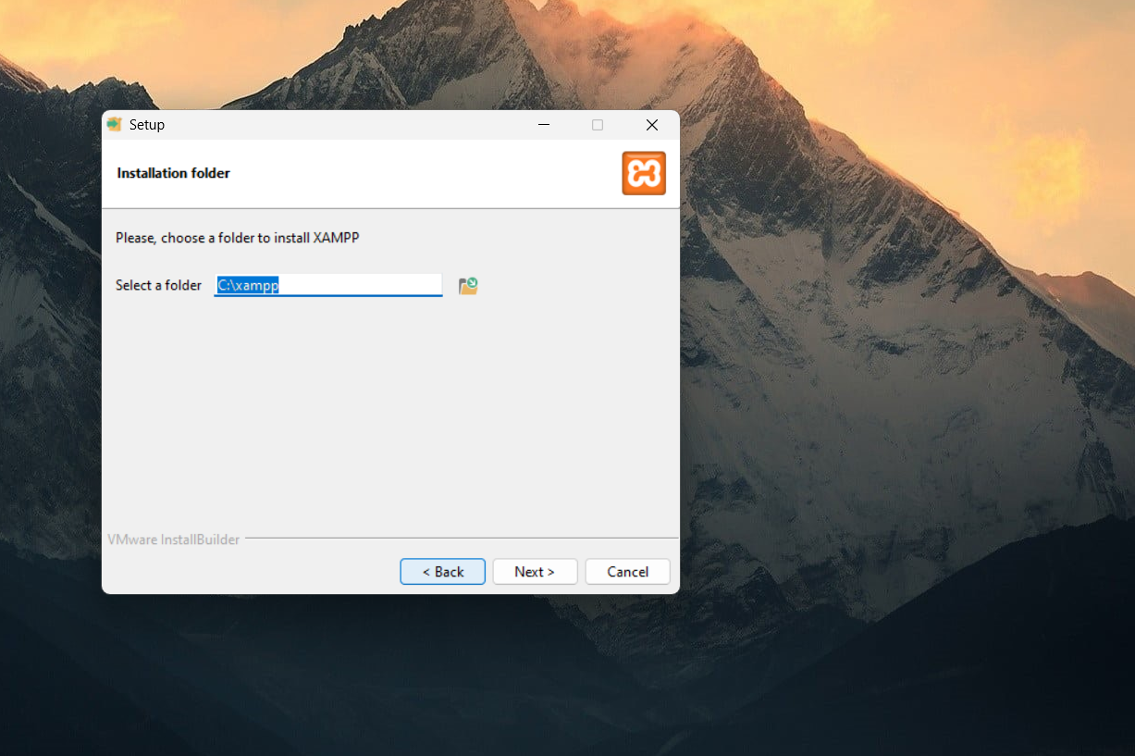

1. Select the directory where you want to install XAMPP. The default directory is usually C:\xampp on Windows or /Applications/XAMPP on macOS.



1. Click "Next" through the subsequent prompts until you reach the "Ready to Install" screen.

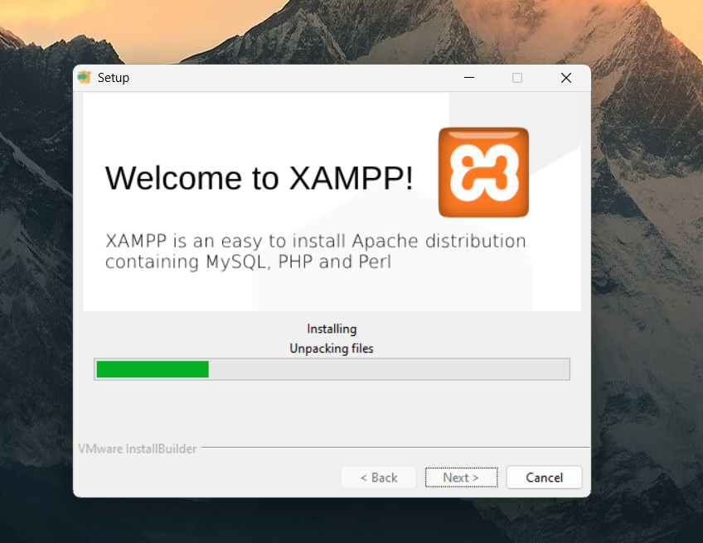

1. Click "Next" again to start the installation process. This may take a few minutes to complete.



1. Once the installation is complete, you will see a "Setup Wizard Completed" screen.

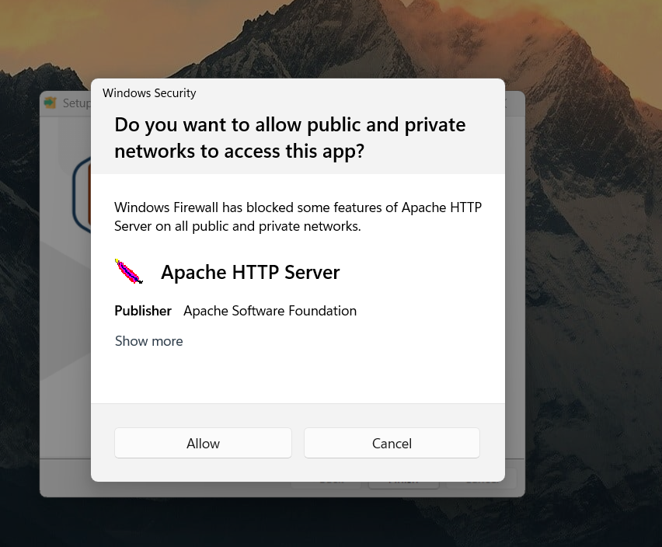

1. Click "Finish" to close the installer. Optionally, you can choose to start the XAMPP Control Panel immediately.

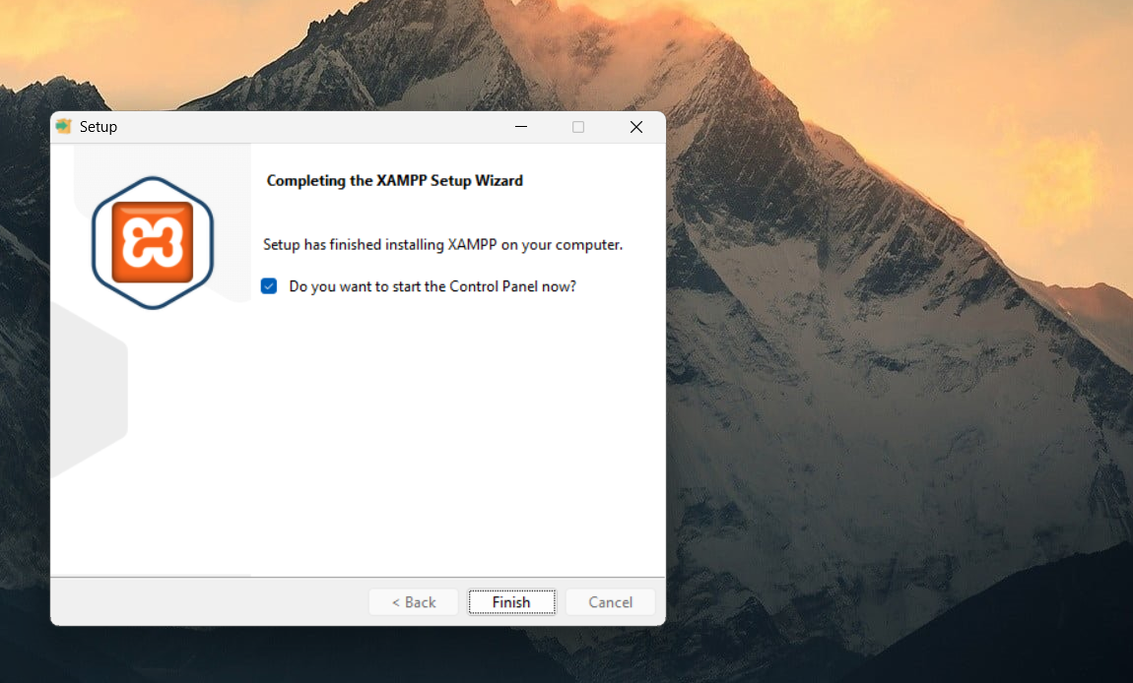

1. Open the XAMPP Control Panel. On Windows, you can find it in the Start Menu under "XAMPP" or by navigating to the XAMPP installation directory and running xampp-control.exe.

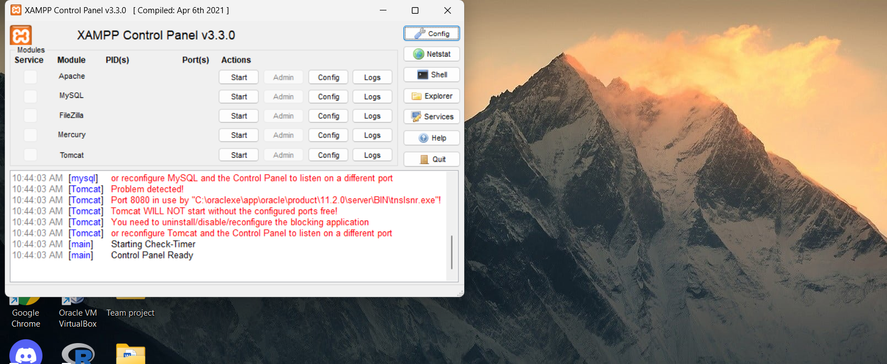

1. In the XAMPP Control Panel, click the "Start" buttons next to Apache and MySQL to start these services.

